Support for Children and Families

THS Supporting Families Offer
Trinity High School recognises the challenges families face in bringing up children and acknowledge these challenges can arise at any point throughout childhood and adolescence. Our Early Help Offer includes universal and targeted services designed to reduce or prevent specific problems from escalating or becoming entrenched.
At Trinity High School we understand asking for help can often feel like the hardest step, but we genuinely want to help you if we can do so. If you, or someone else within our school community needs extra help and support, please come and talk to us. There are many ways in which we can help as outlined in this offer of early help. We can also help to plan specific support for families if appropriate. The diagram below shows the range of needs at different levels. We use this graduated approach to make sure we provide the best support for different families’ individual situations.
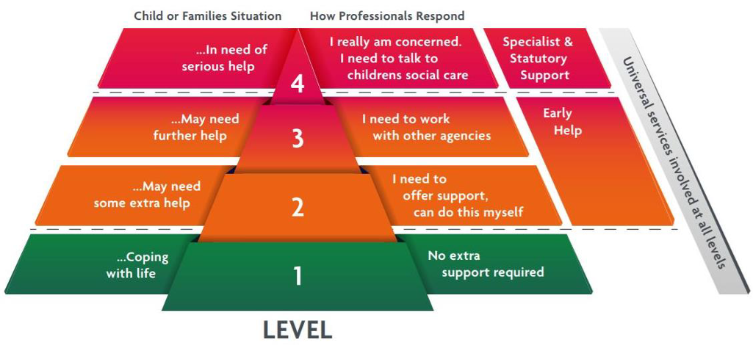
Early Help is everybody’s responsibility: together we will make sure that children, young people and their families are safe, happy and ready for school, work and life’s challenges.

Our coordinated Supporting Families Offer is outlined below. We strongly believe that early interventions for students and families, in many cases, will prevent children from experiencing harm. All Trinity High School staff are aware of our Supporting Families Offer. At all times, staff consider if there is any offer of early help that we can make in order to help a student thrive. In addition, where appropriate we also liaise with other agencies and support services within the local community.

Key Personnel and job roles:
Designated Safeguarding Lead (DSL): Lucy Chinn, Assistant Headteacher chinnl@trinity.bmat.co.uk
Deputy DSL’s are:
Stephen Kearns (Headteacher) kearnss@trinity.bmat.co.uk
Ruth Bennett (Deputy Headteacher) bennettr@trinity.bmat.co.uk
Helen Dukes (Safeguarding DSL) dukesh@trinity.bmat.co.uk
Natalie Mills (Student Welfare and Early Help Officer) millsn@trinity.bmat.co.uk

Our Supporting Families Offer
Early Help is a pathway to supporting you and your child as they grow up when you or they may need further support or guidance.

Providing early help to our pupils and families at Trinity High School means we can improve outcomes for children, families, and communities, providing support as soon as a problem emerges, at any point in a child’s life, from the early years through to teenage years.
Early Help can support children and their families who may be struggling with:
- Routines and family rules
- Families who may not be eating healthy food
- Keeping to a healthy lifestyle
- Children who are caring for a family member
- Children who may not want to go to school for different reasons
- Disability within the family including children being a young carer
- Children in the family have special educational needs (SEND)
- Children who may becoming involved in anti-social or criminal behaviour
- Children who go missing from home
- Children or parents / carers misusing drugs or alcohol
- Children at risk of being tricked, forced, or made to work in the criminal world
- Children who may need support because they may live in a home and see drug or alcohol abuse or adult mental health problems.
- Children who have parents who argue a lot (and sometimes might hurt each other) whether the parents live together or apart.
- Children at risk of being groomed to join groups which support illegal views
- A privately fostered child (a child from another family living within your family home)

Early help relies upon local groups and people in the community, sometimes we work together to help children, young people, and their families.

Everyone needs help at some time in their lives and therefore an ethos of early help is important for any school.

Tutor System

All students have an allocated form tutor who they see on a daily basis. This is their first point of contact for any issues, and parents also have email access to their child’s tutor. In addition, there are scheduled parental meetings, but parents are encouraged to liaise more regularly as required. Tutors are responsible for overseeing the academic and pastoral wellbeing of their group, and liaising with other staff within the school as required to ensure that the appropriate support is in place as soon as a need is identified.

Heads of Year and Pastoral Managers

All students have an allocated Head of Year. Our Heads of Year are skilled and experienced professionals who work hard to support students and their families, having oversight for all pastoral, behavioural and attendance matters. If you or your child needs someone to talk to or you need support with particular difficulties, they can be contacted at the school. Heads of Year can help with a range of things, including problems with coming to school, friendship issues and issues around confidence. Heads of Year are also there to help our parents and give support with parenting issues; remember, from time to time we all experience difficulties. Having someone to listen and offer support can be of great help.

Our Year teams are:

Year 9:
Mr Kesterton kestertond@trinity.bmat.co.uk
Mrs Harvey harveys@trinity.bmat.co.uk

Year 10:
Miss Rowley rowleym@trinity.bmat.co.uk
Miss Lester lesterl@trinity.bmat.co.uk

Year 11:
Mr Green greens@trinity.bmat.co.uk
Mrs Senior seniorm@trinity.bmat.co.uk

Year 12 & 13:
Mrs Loader loaderk@trinityhigh.bmat.co.uk

Special Educational Needs & Disabilities Team

Trinity High School’s SEND team is led by Mr Marshall, who is supported by Mrs Rock. Their focus is on co-ordinating support for students with special educational needs and disabilities (SEND) and developing the school’s SEND Policy to make sure all students get a consistent, high-quality response to meeting their needs in school.
If you have any concerns or queries about your child’s SEN needs, please contact a member of the SEND team:
Mr Marshall – marshalls@trinity.bmat.co.uk
Mrs Rock – rockc@trinity.bmat.co.uk

Further information about our SEND offer is available on our website.

Mrs Mills is our Student Welfare and Early Help Officer. She provides support to parents, students and families.
Mrs Mills millsn@trinity.bmat.co.uk

Local Services

Early Help Family Support Service:
The Early Help Family Support Service is delivered by Worcestershire Children First directly to families permanently living in Worcestershire who have children aged 0-18 years old and need help and support specifically from a Family Support Worker. For more information, please visit: Worcestershire Children First Early Help Family Support Service | Worcestershire County Council

Health (including mental health, emotional wellbeing, and sexual health)

The Starting Well Partnership offer a range of health services which support both children and families experiencing a range of health issues.

Worcestershire Health Visiting Service | Starting Well (startingwellworcs.nhs.uk)

If your child is under 5 years old and you need advice on issues such as feeding, behaviour, or toileting you can contact the Telephone Advisory Service on 0300 123 9551 (Monday – Friday 9am until 3pm).

A Health Visitor will assist you over the phone with any worries, concerns, or questions you have.

School Health Nursing | Starting Well (startingwellworcs.nhs.uk) Redditch Team 01905 520032
School health nurses offer a range of services such as home visits, health needs assessments, time4u drop-in service, school aged hearing and national child measurement programme to support the needs of children and their families.

Text service supporting young people | Latest news, updates and opportunities | Starting Well (startingwellworcs.nhs.uk)
Chat health is a free and confidential text service for young people in need of advice or support
TO CONFIDENTIALY CONTACT YOUR SCHOOL NURSE, TEXT: 07507331750
Social Prescribing :: Onside Advocacy, Worcestershire (onside-advocacy.org.uk)
Social Prescribers support you to take control of your health and look after yourself by making connections with the different types of community support available.

I am worried about my Child's mental health | Herefordshire and Worcestershire Health and Care NHS Trust (hacw.nhs.uk)

Home - Kooth
Kooth is an online mental wellbeing community which offers free, safe, and anonymous support.
Reach 4 Wellbeing | Herefordshire and Worcestershire Health and Care NHS Trust (hacw.nhs.uk)
The Reach4Wellbeing team promotes positive wellbeing to reduce the stigma of mental health by providing short-term group programmes for children and young people age 5-18 experiencing mild to moderate anxiety and low mood.
Papyrus UK Suicide Prevention | Prevention of Young Suicide (papyrus-uk.org)
Papyrus can offer suicide prevent support providing free and confidential helplines, advice, webchats, and resources.

Home | Healthy Minds (whct.nhs.uk)

Winston's Wish - giving hope to grieving children (winstonswish.org)
Winstons Wish provide support for children and young people following the death of a sibling, parent, or a person important to a child.

Melo - Mental Health & Wellbeing Resources, Courses & Support

Melo is a comprehensive mental health resource offering a variety of support, self-help resources, and courses aimed at improving mental well-being.

Sexual Health Sexual health | Sexual health | Worcestershire County Council

Worcestershire Integrated Sexual Health Service (WISH) | Herefordshire and Worcestershire Health and Care NHS Trust (hacw.nhs.uk)

WISH offer friendly and non-judgemental specialist services to support with information and advice, contraception, pregnancy, STIs and screening.
Under 21 Saturday Service - Clinic telephone lines are open between 10:00am – 12:30pm on Saturdays - Please call: 01905 681673 for further details.
Young People have a telephone consultation and are asked questions about their relationships. Callers will be advised what to do next and directed towards a clinic if necessary.
WISH have a dedicated Outreach nursing service. Referral forms can be found at www.knowyourstuff.nhs.uk The Outreach team see young and vulnerable people who couldn’t otherwise access sexual health services.

Free STI test kits and contraception: SH:24 Free Home STI STD Test | Sexual & Reproductive Health (sh24.org.uk)

Bullying (including Cyberbullying)
If you are concerned your child or a child, you know is being bullied there are several services and useful links which can help you support your child as a parent.

In the first instance if bullying is happening at school, please speak to a member of staff who will be able to help.

The following links will provide you with more information if you or someone you know is being bullied:
Is your child or someone you know being bullied? | Is your child or someone you know being bullied? | Worcestershire County Council
Are you being bullied? | Are you being bullied? | Worcestershire County Council
Cyberbullying | Cyberbullying | Worcestershire County Council
https://www.kidscape.org.uk/resources-and-publications/

Online Safety
If you have concerns around the safety of your child or a child you know online, the following links will provide you with information, support, and advice to help understand the risks and keep your child safe online:
- https://www.thinkuknow.co.uk/parents/
- Online safety | Barnardo's (barnardos.org.uk)
- http://educateagainsthate.com/
- www.internetmatters.org
- https://www.bbc.com/ownit/the-basics/8-tips-for-staying-safe-online

The sending or receiving of nude or semi-nude images, videos or conversations online, often known as ‘sexting’, is something you may wish to learn more about. The following links are a good starting point:
Sexting and sending nudes | NSPCC
https://www.thinkuknow.co.uk/parents/articles/Nude-selfies-a-parents-guide/

Relationships

The following services and links offer information, advice, and intervention on healthy relationships for your family and children:
Healthy relationships | NSPCC

Challenges at home: Harmony at Home – information and support for parent carers | Harmony at Home – information and support for parent carers | Worcestershire County Council

CRUSH is an awareness raising and support programme to help young people make safe and healthy relationships. http://www.westmerciawomensaid.org/crush/

Relationships | The Family Hub | Worcestershire County Council

Friendships and relationship in teenagers
Making friends and starting new relationships are a big part of getting older. It's very common to fall out with friends or break up from relationships – which can be very difficult to deal with. You might also be in a relationship that doesn't feel right and need some advice about what to do. The websites below contain lots of information about making friends, peer pressure, healthy and unhealthy relationships, sex and much more. There is also information available for parents around how to talk to your child about friendships, sex and relationships.
Childline - Friends, relationships and sex (opens in a new window)
Disrespect Nobody - Signs to spot (opens in a new window)
NHS Choices - How to talk to your child about sex (opens in a new window)
NHS Choices - Sex and young people (opens in a new window)

SEND (Special Educational Needs and/or Disabilities)

If you are looking for information or advice the following links will help you:
SEND Local Offer | Worcestershire County Council or contact localoffer@worcschildrenfirst.org.uk

SEND Information, Advice, Support Service SENDIASS Worcestershire and Herefordshire (hwsendiass.co.uk)

Social care support for children with disabilities | Social care support for children with disabilities | Worcestershire County Council



The Online Family Hub has been developed to provide you with a range of different types of resources that are available to you online, on the phone or face to face that you can access directly.

The Family Hub can offer you support and information with the challenge’s family life can bring.

The Family Hub | Worcestershire County Council
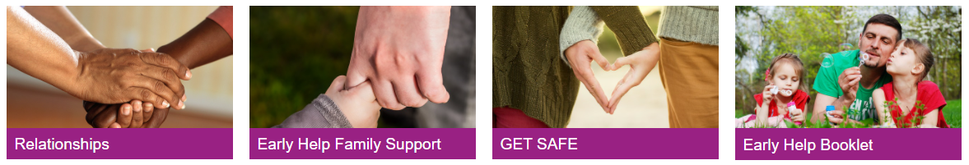

Early Help in Worcestershire have created a booklet to help families find out about the help and support available in the county for children and young people aged 0-18 years old. The new booklet will help you and families find the most appropriate support.
To download this booklet, please visit: The Family Hub | Worcestershire County Council

Worcestershire Young Carers

Worcestershire Young Carers aim to identify, and support children and young people aged 7 to 24 years who have a caring role within the home and help look after a parent, sibling, or grandparent due to illness, disability, physical or mental health difficulties or substance misuse.
Worcestershire Young Carers/Shropshire Young Carers | YSS

Carers | Worcestershire County Council

Please contact your child’s Form Tutor or Pastoral Team if you believe your child is a young carer so that support can be offered.

Finance, Housing and Employment
If you are facing challenges around employment and income, please contact the local job centre who can with offer support with jobseekers’ allowance, incapacity benefit, employment and support allowance and income support:

Local Job Centre Plus,

Worcester Job Centre Plus, Haswell House, Sansome Street, Worcester, WR1 1UZ
Telephone: 0845 6043719
Citizen’s Advice Bureau Worcester Citizens Advice – Worcester Citizens Advice Bureau and WHABAC (Worcester Housing and Benefits Advice Centre) (citizensadviceworcester.org.uk)
Building Better Opportunities is a service to help local people move closer to employment. Building Better Opportunities (fusionworcs.co.uk)
For information on what financial and housing support is available in Worcestershire, please visit:
Housing and finances | The Family Hub | Worcestershire County Council
Parenting Support

The Starting Well Partnership offer a range of parenting support, information, groups, and courses. For information on the groups available please visit: Parenting groups | Starting Well (startingwellworcs.nhs.uk)

Parenting Talk is an online hub offering information, advice, and a free confidential online chat with a parenting advisor.
Parent Talk - Support for Parents from Action For Children

Homestart can work with you to provide one to one support in the family home each week. This service provides support tailored to your needs and can help you as parents they learn to cope and build confidence to provide as best you can for your children.
Home-Start | South Worcestershire (home-startsw.org.uk)

In England, under the NHS, you now have a legal right to choose your mental healthcare provider, including for Autism Spectrum Disorder (ASD) and Attention Deficit Hyperactivity Disorder (ADHD) assessments. This service, offered through the NHS, is free of charge.
Right to Choose: ASD & ADHD Assessment Pathways - Cuckfield Medical Practice

Family Information Service
Do you need advice and support around finding childcare? The following link will provide you with the contact details of the Family Information Service’s District Teams: http://www.worcestershire.gov.uk/info/20507/childcare/1579/family_information_service

Substance Misuse

Swanswell - Cranstoun
Here 4 Youth is support service for children and young people up to the age of 18 who may be struggling with their use of drug and / or alcohol. Here4YOUth Worcestershire - Cranstoun
Do you have a family member in prison?
Do you have a family member in prison which is having an impact on your child? Support is available to work with both the person in prison and your family.
NICCO

Families First provides support and guidance in a safe space, to enable the whole family to cope with the demands of having a partner, and parent, in prison: Families First | YSS

Get Safe

If you are worried your child is at risk of being tricked, forced, or made to work in the criminal world please speak to a member of staff and visit Get Safe for help and information:

https://www.worcestershire.gov.uk/GetSafe-keepingchildrenandyoungpeoplesafefromcriminalexploitation

If you are experiencing any of these challenges or issues affecting family life, please contact a member of staff who will be happy to provide you further advice and support.

