Skills Evidence Booklet – Music

Paper 2:
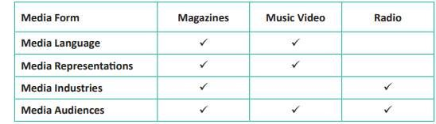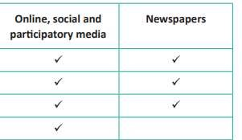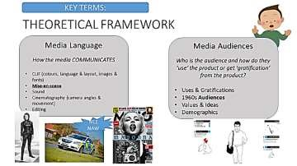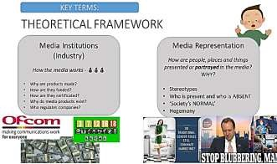

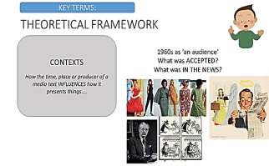

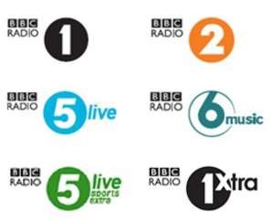
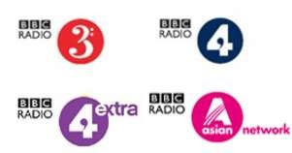
W
ARM
U
P

–

10

MARK

What is the main difference betwee
n commercial and BBC radio? [1]

Who is BBCR1 Live Lounge’s presenter? [1]

What time do
es BBCR1 mid
-
morning show start
and finish? [1]

What is meant by the term ‘visual radio’? [1]

How does BBC radio (across its stations) cater for the entire UK
population
[3]

How can ‘The Live Lounge’ be considered ‘widely available’? [1]

Which BBC radio station is a MOJO reader most likely to listen to? [1]

Which BBC radio station is a Vamps / Little Mix fan most likely to
listen to? [1
]

Marks out of 10:

