Skills Evidence Booklet – News
Paper 1:
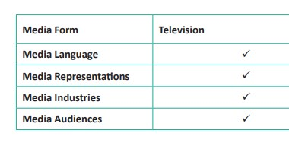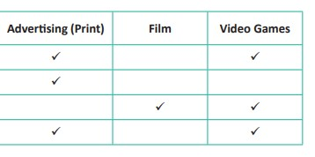

Paper 2:
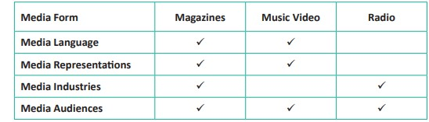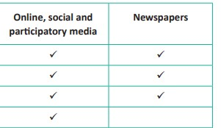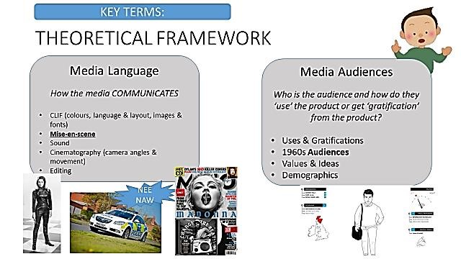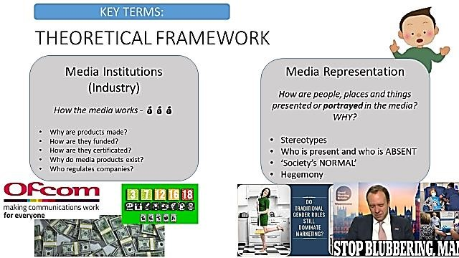

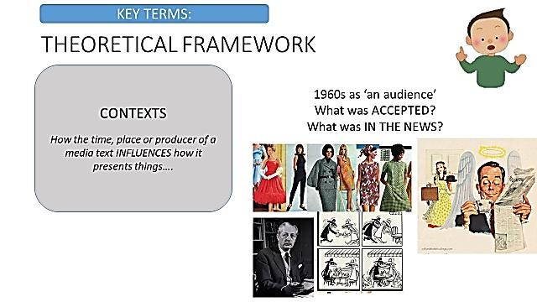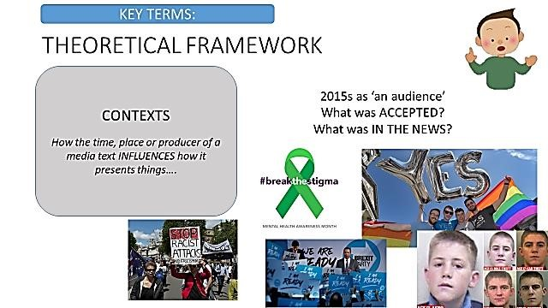

WARM UP
Label the key features of a newspaper:
Masthead | Date / Issue | Caption
Pug | Cover Price | Support story
Pull Quote | Page Reference | Main image
Puff | Additional Image | Standfirst
Headline | Rule | Byline

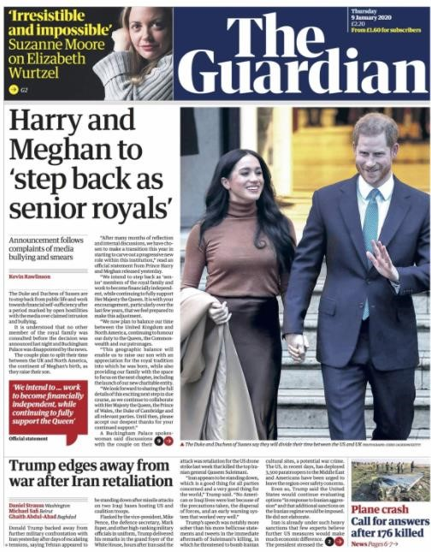

Task:
Fill in the table to explain the differences between tabloid and broadsheet newspapers.
 |  | TABLOID |  | BROADSHEET
Images : Text
Fonts
Language
Layout / Size
Cover Price
News Style
Readers
Name 2 tabloid and 2 broadsheet newspapers. Task:
Linking ideas – link the newspaper features to the reader profile. Use examples from the images as evidence.
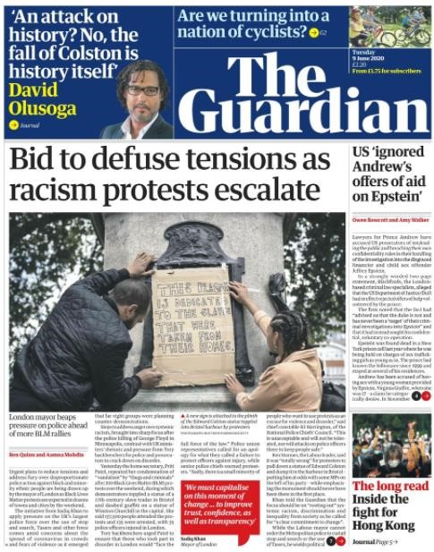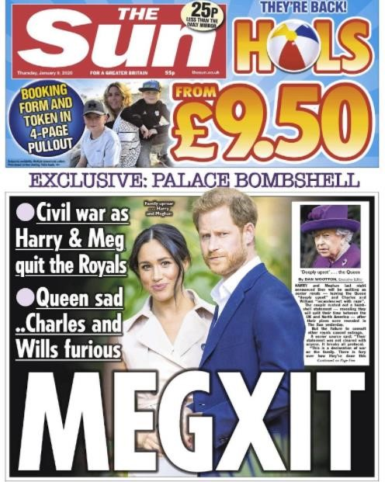

Cover Price  - - Reader Use ‘in comparison’ | The cover price of The Sun is 55p which appeals to the C2DE reader, whose disposable income might be lower. The Sun are also advertising that they are 25p cheaper than other newspapers, another appealing factor to lower earners.
Language - - Reader Use the word
‘however’
Images : text - -
Reader
Use ‘in contrast’

WARM DOWN
The Guardian rebranded recently – it is now a similar size to a tabloid (it’s Berliner sized) and focuses on soft news (celebrity, food, arts) on the cover as well. Give 4 reasons for this rebrand.
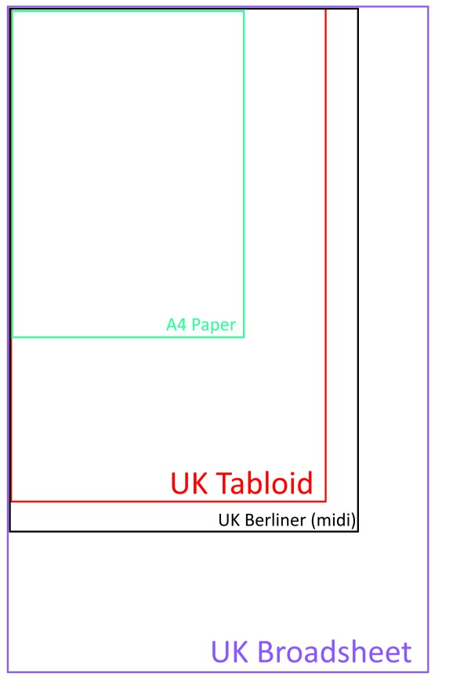
WARM UP
Using the graphs and identify 6 facts about the readers of The Guardian.
Top marks: compare to other papers – is The Guardian ‘the most’ or ‘the least’ of anything?
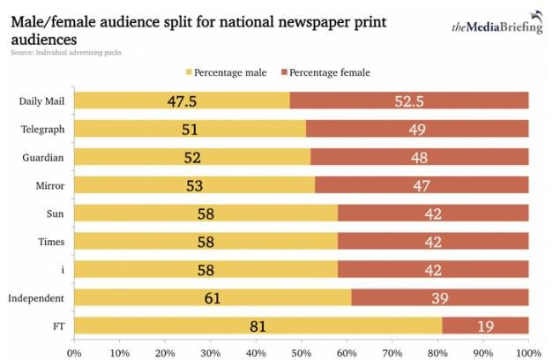 | 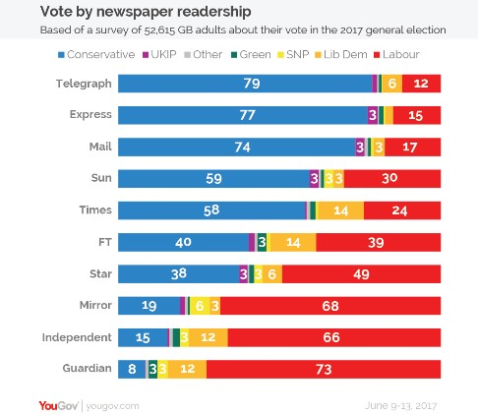
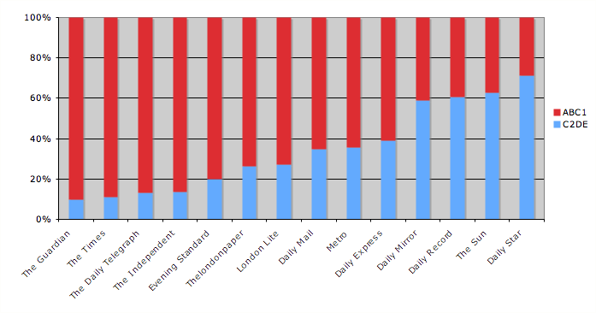 | 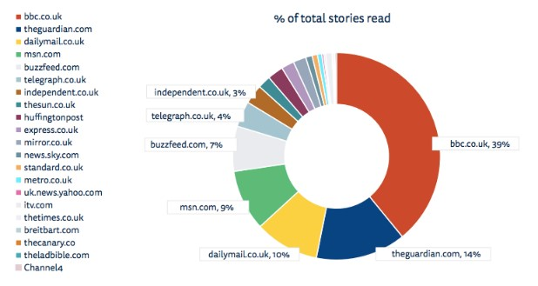
Add detail - What can we find out about the average reader’s lifestyle and interests?

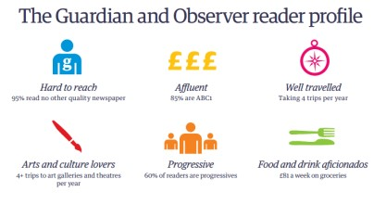

Task:
Guardian & Observer reader values are ‘liberal’. Use the information about liberal government and The Scott Trust Values to analyse the quotations.

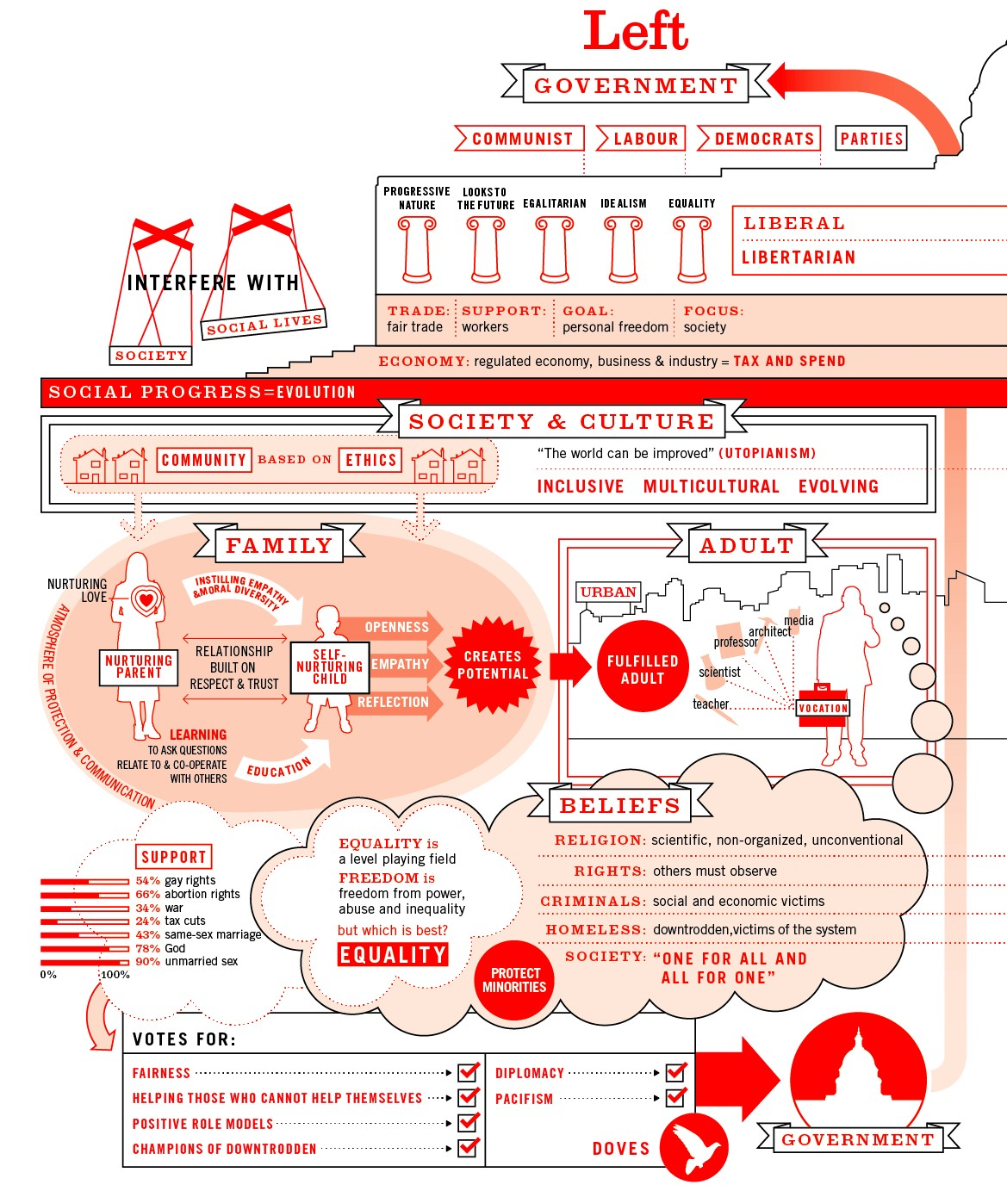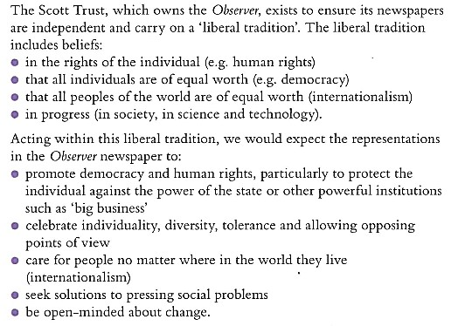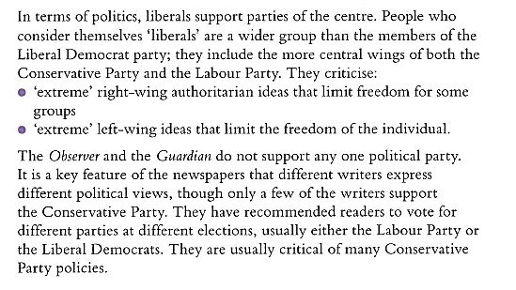

I don
’
t think the UK
government
should give

so much

money to other
countries,

tax payer
’
s

money should be spent on our people and our problems.

W
h
at
makes life interesting

is everyone having
different ideas and opinions. If we were all
the same it
’
d be very boring!

We must make sure that
everyone has the same opportunities open to them, no matter
where they are from, their gender or their beliefs.

Climate change is a hug
e problem. We all need to do our

bit, no matter how small, every little

thing we
do

makes a difference.

I think
you should vote for the same party every time you vote.
You shouldn
’
t switch sides.

I think
technology has a really positive impact on our lives and that
we should develop the use of tech in any way we can.

All people should have the same rights, whether male
, female, trans, gay,
heterosexual
,
rich, poor, educated or not.

WRITE TWO MORE STATEMENTS WHICH MIGHT FIT THE BELIEFS OF A GUARDIAN READER.

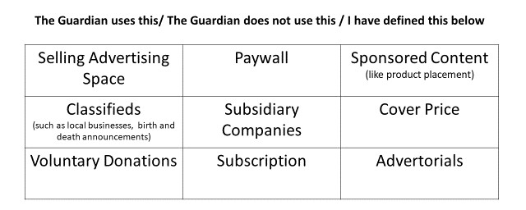
CHOOSE 3 OF THE TERMS AND DEFINE THEM:
1)
2)
3)

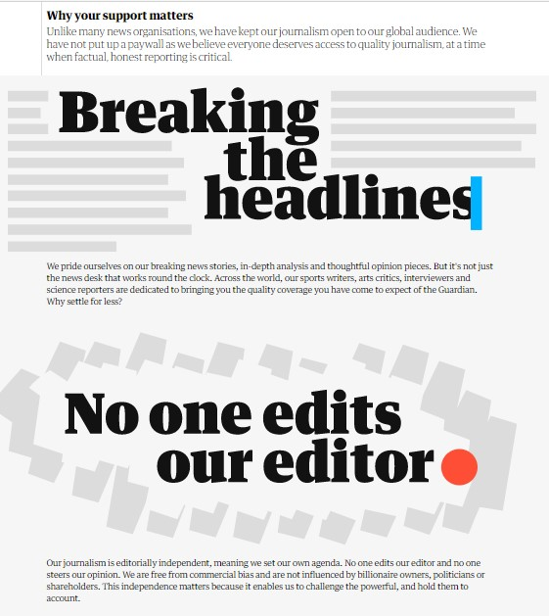
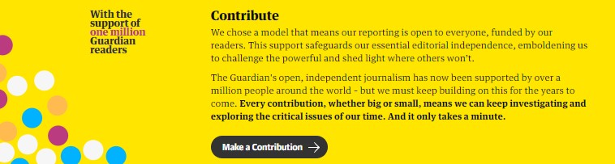
Why do you think The Guardian is the only newspaper to offer a voluntary donation for its work?

Why do you think this model has been successful?

Task:
In 2020, an estimated 480,000,000 read stories from The Guardian online every month – data from: https://otechworld.com/most-popular-news-websites/ Label the ways in which The Guardian ONLINE offers readers different experiences to those reading the paper-based newspaper.

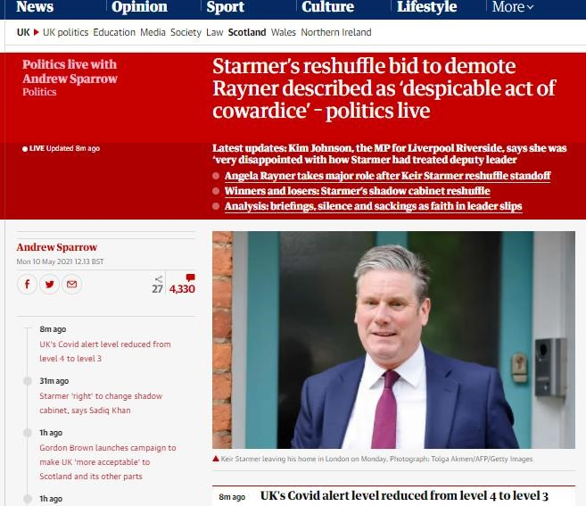

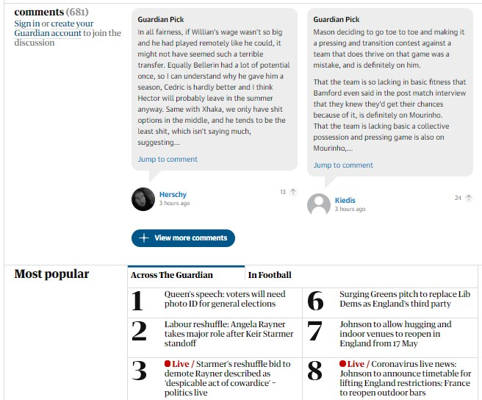

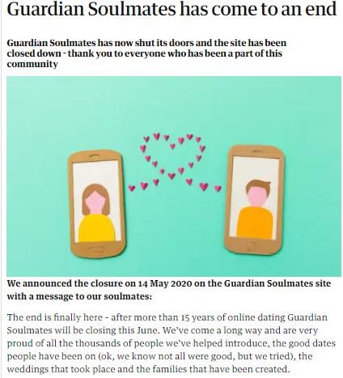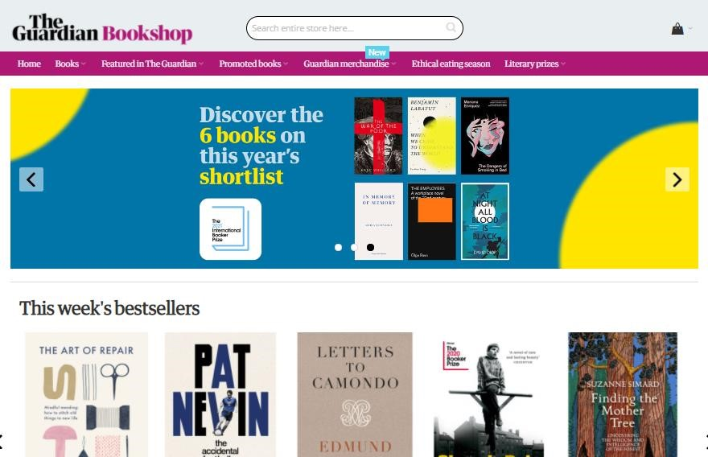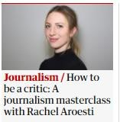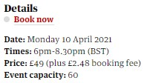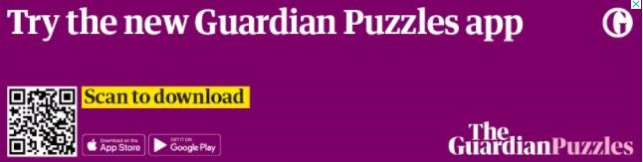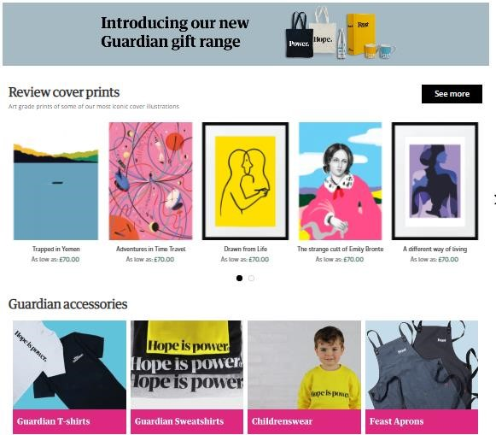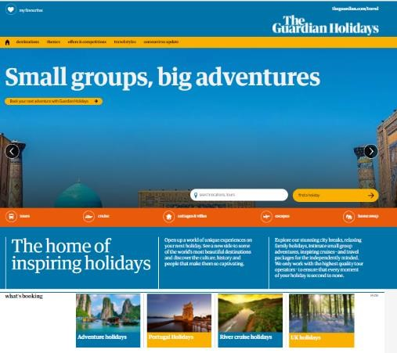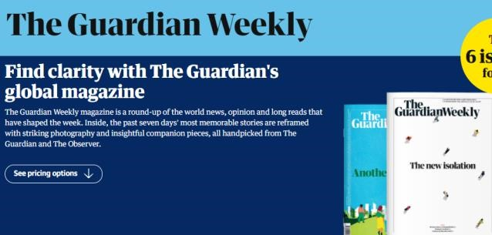
W
ARM
D
OWN
:

Often people buy
a particular
newspaper
as they believe
it

says so
mething
about them as a person
.
Readers select newspapers
because the
ir values are
reflected
in the content
–

you
wouldn
’
t want to rea
d
news stories w
hich told
you your opinions w
ere
w
rong all the time!

To make
extra

reven
ue
(
money),
The

Guardian has many
diffe
rent companies
/ subsidiaries
which
m
ake profit and
,
at the same t
ime, still
fit
wit
h the values

of its rea
ders.
Ma
ke notes on
how
and why
these exampl
es make money for
the

GMG.

Guardian Masterclass

EXTRA T_{ASKS}
The Guardian is different to other newspapers in the way it is regulated. Following the _________ inquiry, newspapers were encouraged to join a regulator which would hold them to account if illegal or unethical things had happened. This inquiry started because of the _______________________ scandal where it was decided several newspapers had acted unlawfully to get information for their stories. Two press regulators were set up: ________ and __________. It was decided that ________ wasn’t a suitable regulator because it is run by ___________________________ and therefore might influence newspapers, which should be free press. The Guardian, however, refused to join either regulator. Instead they
_____________________________ by having a board of independent editors to review complaints. This is run by __________________________________, which owns the Guardian ______ Group.
IPSO | The Scott Trust | government
Self-regulate | Leveson | IMPRESS
media | OFCOM | phone-hacking

NAME THE SHOT TYPES:
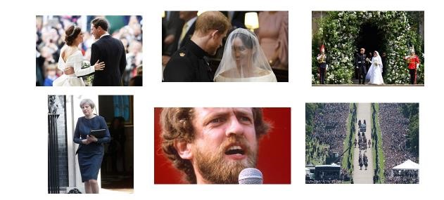
NAME THE CAMERA ANGLES:
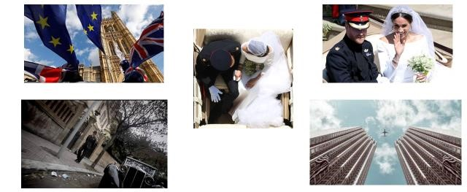

Choose 6-8 of the 12 stories on the grid (taken from The Guardian’s Instagram account).
Why would readers be interested in these stories?
Which of the Scott Trust / Liberal values are demonstrated?
How is the branding of The Guardian / Observer used in the Instagram feed?

