Skills Evidence Booklet – Music

Paper 2:
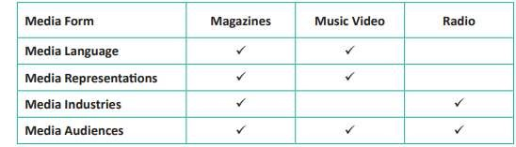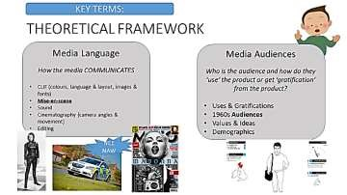

Task 1: How are these artists represented using mise-en-scene? Are there any links to genre?

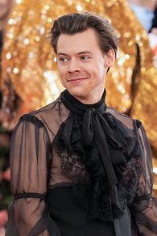

Task 2: Create a key and use 3 colours to link these ideas to Adore You and Hope
Musicians live extreme or dangerous lives. | Young people are attractive, slim and ablebodied. | Intelligent girls are unattractive to males. | Compassion for others is powerful
Females are there to be ‘looked at’. | Girls often have to compete to get male attention. | Teenagers love to have fun and dance. | Rock / punk musicians are rule breakers.
The beach is a place of fun. | Love or attraction is limited to heterosexual couples. | Musicians are people to be admired or  ‘worshipped’ | Young people are social  – often in groups together.
Key idea: Stereotypes

Task:
Explain how the use of narrative & setting may appeal to Arlo Parks’ audience.

Read the student’s response to the question: How do the two music videos you have studies differ from one another? Note this is for different music videos.
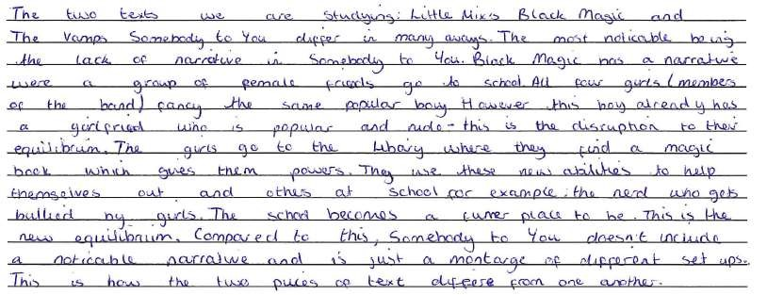
Add to this answer by identifying one more way the two music videos you study are different from one another:

Imagine the question asked for comparison: Compare the two music videos you have studied. Overall, are they more similar or more different from each other? Make judgements and draw conclusions.
Develop the answer above by presenting one way the music videos are similar to each other.
Top marks: add an ‘overall, I judge’ statement!

