Name:

OCR Media Studies GCSE
Paper 2
Section A: Music
5 Questions MOJO, music videos & Live Lounge
Section B: News

5 Questions The Observer print & online

The Theoretical Framework
Language = ways in which media text communicate meanings  Mise-en-Scene - lighting, setting & location, costume & make-up, facial expression & body language and positioning of characters in the frame (proxemics).  Camerawork - camera shots (close-up, establishing, mid, long, extreme close-up, over the shoulder, high angle, low angle etc.) & camera movement (zoom, pan, tilt, crane, arc, handheld, dolly etc.)  Sound - analysis of diegetic & non-diegetic sound including soundtrack, music, sound effects, dialogue, voiceover, sound editing, volume and pace of sound.  Editing = includes types of cut (straight cut, cutaway, cross cutting, cutting on action etc.) transitions (fade through black, dissolve, iris, wipe, invisible cut etc.), pace and shot length. | Industry = the media companies & business  Production = the making of the media text  Distribution = stage when a product is made available to audiences (includes promotion)  Circulation = how many people consume the media text  Marketing = advertising and promoting to the target audience  Regulation = control of an industry by an authority that checks rules  Globalisation = to operate on a global scale  Conglomerate = large organisation that owns a number of different companies  Convergence = the coming together of media technologies  Diversification = to operate in different media industries
Audience = who an audience is and how they respond to media texts  Target audiences = who the industry is aiming the media text at  Audience demographics = age, gender, social status, economic wealth etc.  Audience theory = Uses & Gratifications theory - Surveillance, Personal Identity, Social Relationships & Entertainment.  Polysemic meaning = how a text can be interpreted and understood in different ways  Active audiences = audiences involving themselves in the production of a text usually through social media  Passive audience = audiences who don’t  engage with a text and passively accept  messages | Representation = how the media portray events, issues, individuals and social groups.  Events e.g. news events, cultural celebrations  Issues e.g. feminism, ownership, regulation  Individuals e.g. gender, celebrity, music artists  Social groups e.g. teenagers, women, the police  Stereotypes = repeated (often negative) depictions of people/social groups  Countertypes = alternative representations to countertypes  Heteronormative = representation of straight relationships as ‘the norm’  Multiculturalism = representations of mixed ethnicity

Paper 2. Section A: Music
5 questions. Live Lounge, music video & MOJO.Question 1 (1 mark)
This question tests your knowledge of the music industry including regulation & ownership.
Preparation: write a short definition of each of the following. What is their link to the music set texts?
MOJO magazine
Bauer media
BBC
IPSO
Diversification
Conglomerate
Radio 1
PSB
Royal Charter
Ofcom
Niche market
Mass audience
Diversity
Distinctive
Convergence
Genre conventions
Globalisation
Product Placement
Multiculturalism
Celebrity culture
Mode of address
Question 2 (4 marks) This question will either be about BBC Radio 1’s Live Lounge or your set pair of music videos (Black Magic and Somebody to You). It is likely to test audience or industry knowledge. You must include specific examples from the set text to support your ideas.
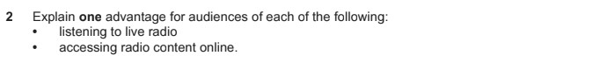
Preparation: prepare for questions about BBC Radio 1’s Live Lounge
 | Explanation | Example
Two ways Live Lounge meets the BBC’s PSB requirements Royal Charter)  reflect UK diversity/ innovative/ distinctive/ promote UK talent | 1
 | 2
One advantage of  - Live radio  - Online radio content analogue/ digital/ web/ BBC Sounds/ Youtube/ Socials | 1
 | 2
Two ways radio shows are promoted to an audience analogue/ digital/ web/ BBC Sounds/ Youtube/ Socials | 1
 | 2
Two ways audiences can  actively engage with radio shows | 1
Two ways audiences can  actively engage with radio shows | 2
 | 1
  Two ways that LIve Lounge
  demonstrates convergence
 | 2
Two ways Live Lounge appeals to the target audience of 15-29 year olds. | 1
 | 2
 | 1
  Two ways Live Lounge reflects
  audience diversity
 | 2

Question 3 (10 marks)
This extended question will be about music video or Live Lounge. You will have to give specific examples from the set text. It is likely to be about audience or representations.
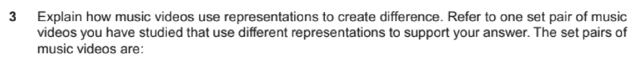
Preparation: Complete the following table with explanations & examples.
 | Arlo Parks ‘Hope’ | Harry Styles ‘Adore You’
Representation of relationships
Representation of masculinity
Representation of femininity
Stereotypes/Anti stereotypes
Representations of
Celebrity/Fame
Representations of
UK/The
City/The Fishing Town/Reality
How audiences are targeted by this video
How audiences my
relate to or identify with the video

Question 4 (5 marks)
Unseen front cover from MOJO magazine provided in the exam focused on language or representation.
Preparation: Complete analysis of theMOJO front covers focusing on language & representations
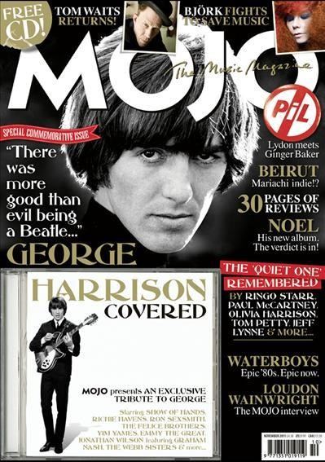 |  | Magazine conventions
 |  | Text/Font
 |  | Image
 |  | Representation of classic rock
 |  | Representation of musicians
 |  | Representation of gender
 | 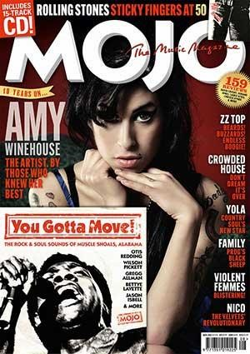 |  | Magazine conventions
 |  |  | Text/Font
 |  |  | Image
 |  |  | Representation of classic rock
 |  |  | Representation of musicians
 |  |  | Representation of gender

Question 5 (15 marks)
This is an extended question focused on media language. You will be asked to compare Extract 1 (MOJO magazine) and another front cover from a different music magazine. You should be able to analyse both extracts using terminology as well as give a clear judgement about the question.
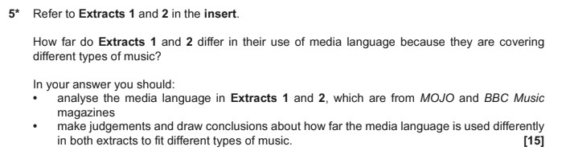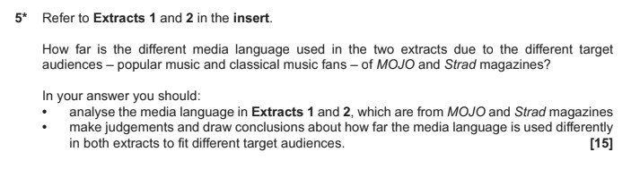
Preparation: Compare and contrast the two covers overleaf across language & representation. Use
magazine codes & conventions to assist you.
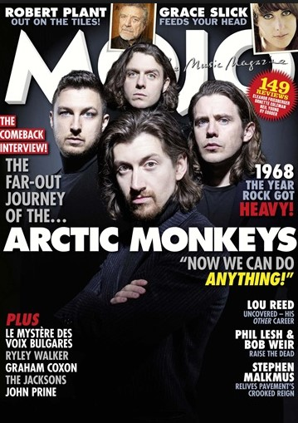
Sell lines
Insert image
Slogan
Masthead
Puff
Main image
Direct mode of address
Anchorage
Pull quote
Coverlines

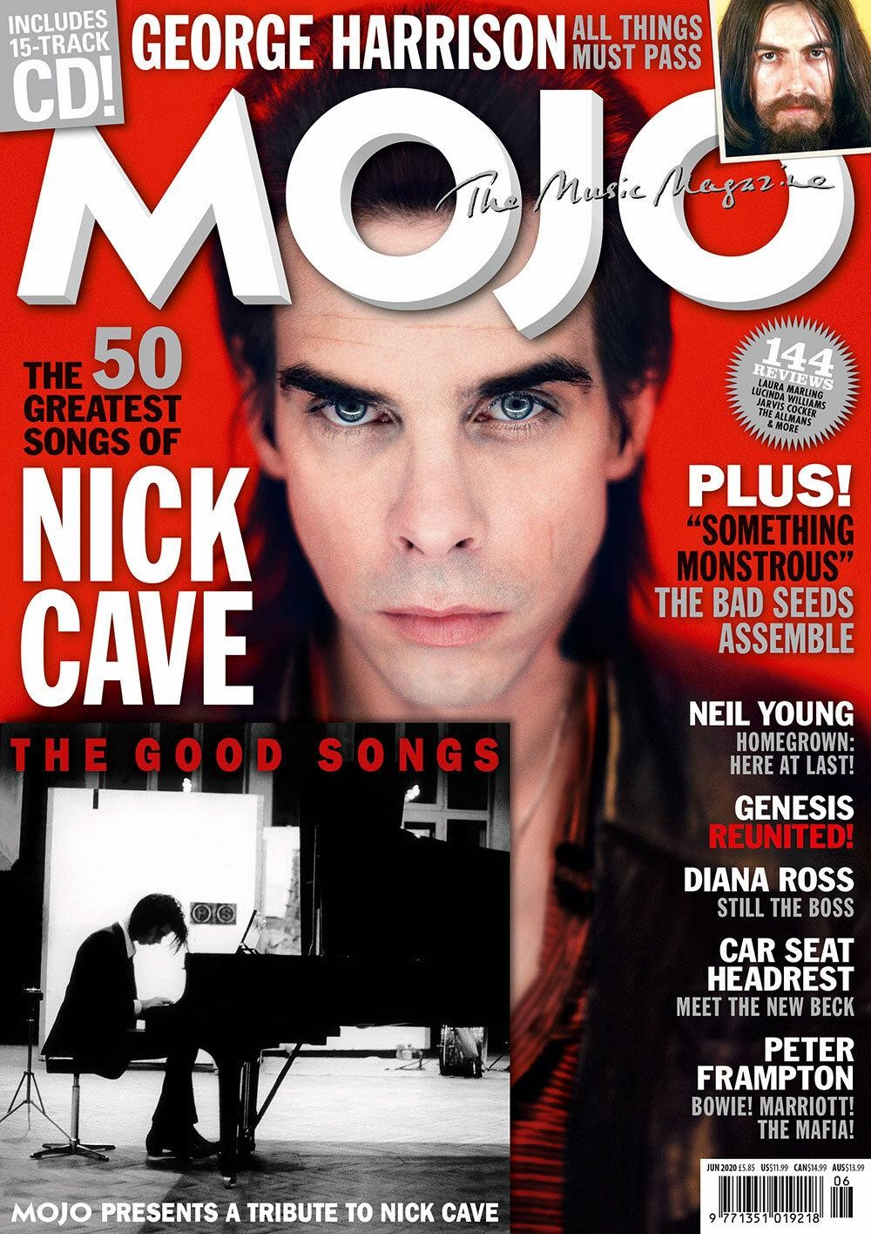 | 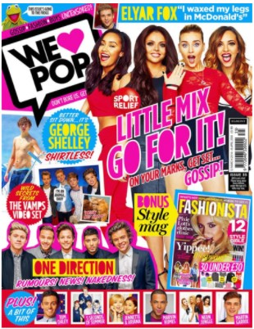
Magazine conventions
Text/Image/Colour
Representation of music genre
Representation of music stars
Representation of gender
Judgement & Conclusion - are they more similar or more different?

Paper 2. Section B: News
5 questions. The Observer 1960s & contemporary print & online.
Question 6 (1 mark) This question tests your understanding of the newspaper industry.
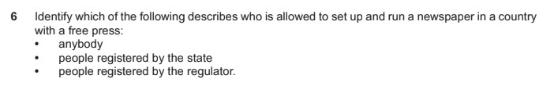
Preparation: Write a definition of each of the following. What is their link to The Observer?
Press freedom
IPSO
IMPRESS
Guardian Media Group
The Scott Trust
Broadsheet
Tabloid
Hybrid
Paywall
Conglomerate
Impartial
Right wing
Left wing
Clickbait
Hard/soft news
Asymmetrical layout
Intertextuality
Serif/sans serif
Skybox
Ideologies

Question 7 (4 marks)
This further tests your understanding of the newspaper industry. You should include real examples from The Observer & other news industry knowledge to support your answer.
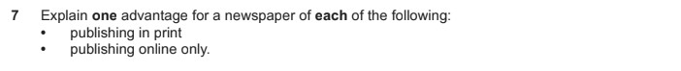
Preparation: Complete the following table:
 | Explan | ation | Examples
Explain two ways the print newspaper industry have diversified online | 1 |  | Online
 | 2 |  | Social Media
One advantage for a newspaper to  - Have an online edition  - Use social media | 1 |  | Online
 | 2 |  | Social Media
 | 1 |  | Online
  Explain why a newspaper
  would shut down its print
  edition and be online only
 | 2 |  | Social Media
 | 1 |  | Online
  Explain two ways online
  newspapers are funded
 | 2 |  | Social Media
t | 1 |  | Online
  Explain how the Observer
  incorporates hard and sof
  news
 | 2 |  | Social Media

Question 8 (5 marks)
This question will ask you to analyse the unseen extract in your exam insert. The analysis could be any key concept and will want you to use examples from the extract & media terminology.
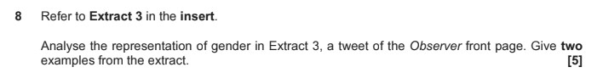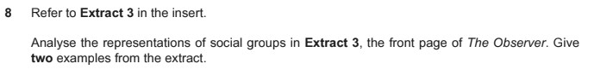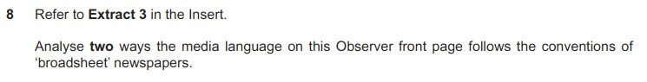
Preparation: Complete notes about the front cover of the extract below:
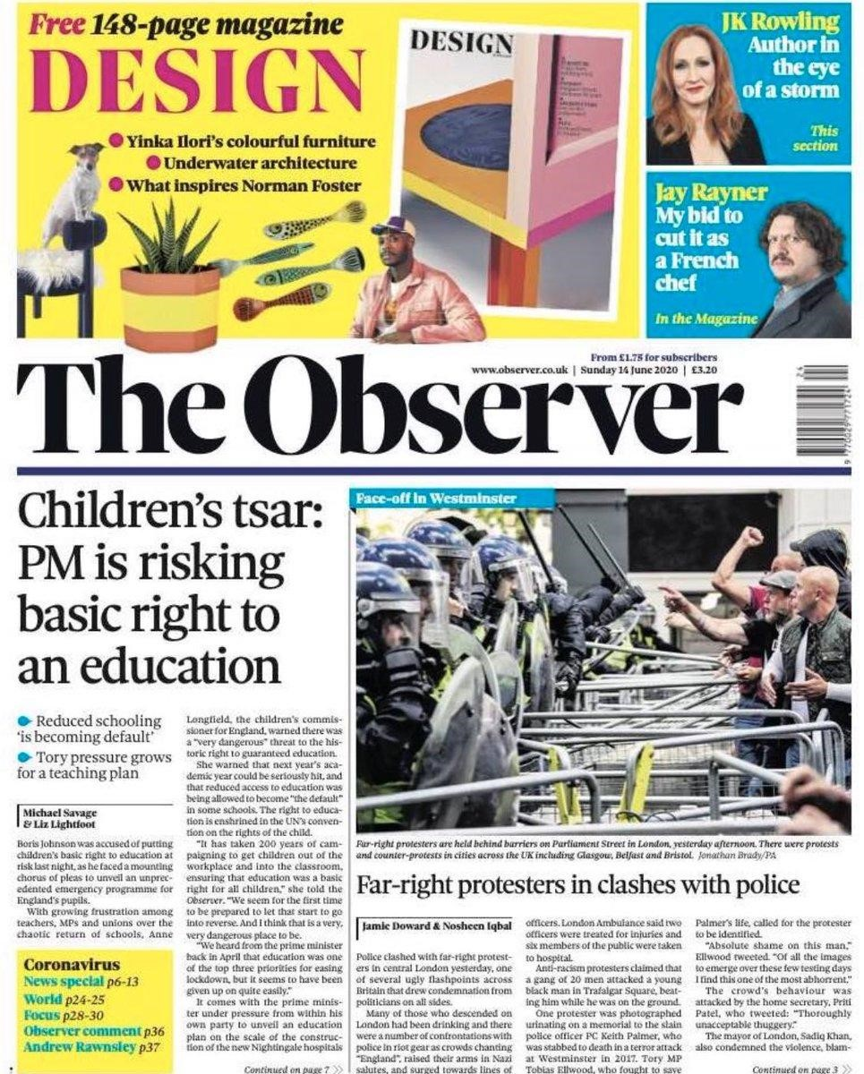 | Genre conventions
 | Image/Colour/Layout
 | Content/stories/topics
 | Representation of women
 | Representation of police/protestors
 | Representation of lifestyle
Values & ideologies of The Observer reflected through the front cover stories
Contexts:

Question 9 (15 marks)
You must analyse the extract & make a clear judgement. In this question it states ‘full course of study’ this means you should cover at least two of the key concepts (LIAR)
You should also include analysis of how the extract reflects ‘media contexts’ this means how it reflects the real world and time that the newspaper was written.
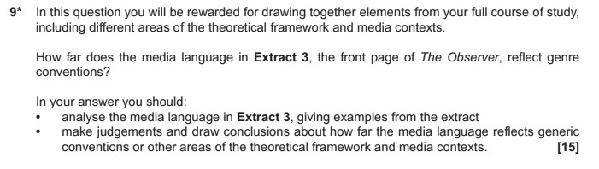
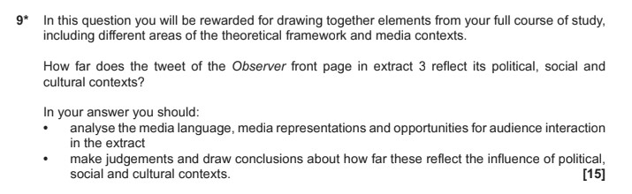
Preparation: Consider how this front cover reflects contemporary ‘media contexts’.
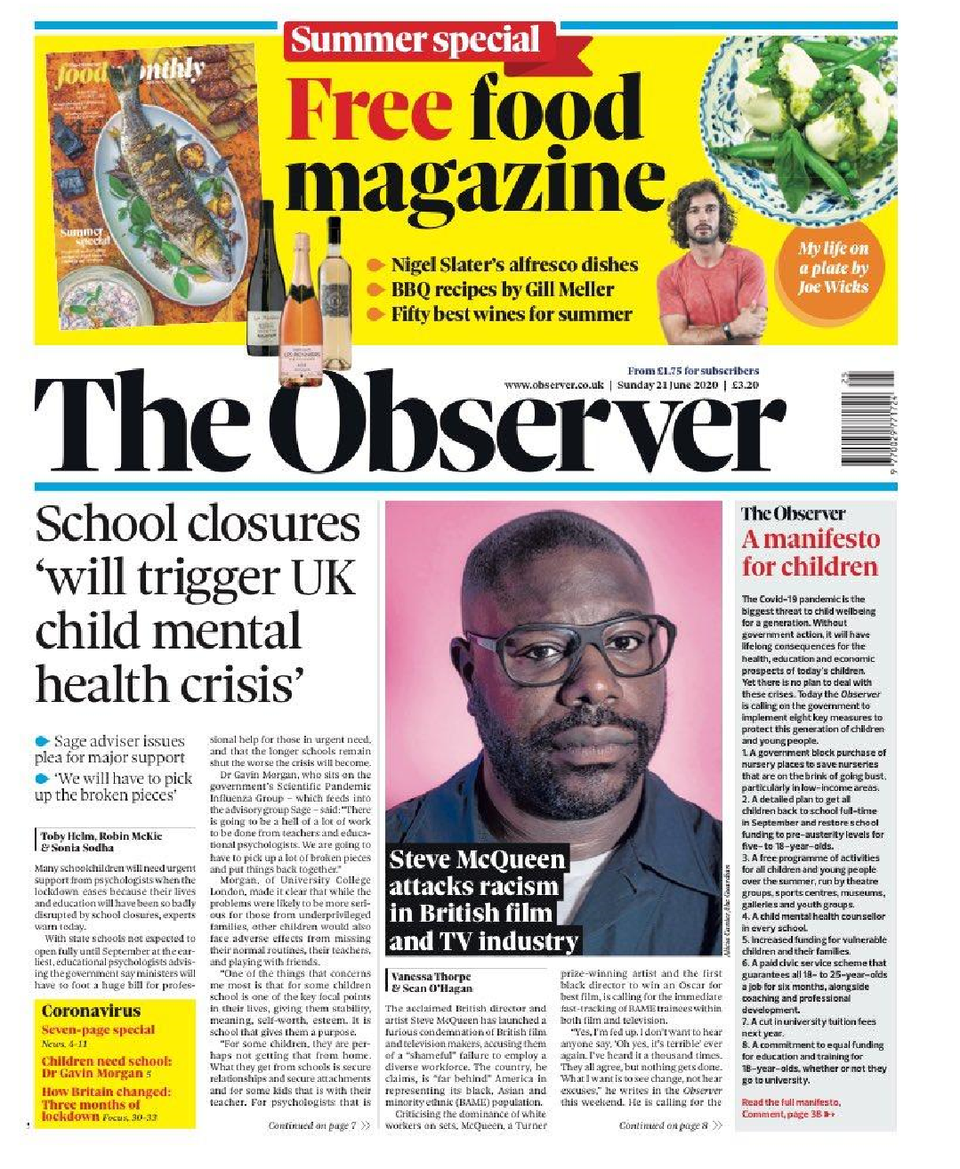 | Gender roles
 | Multiculturalism
 | Lifestyles
 | Democracy/Liberal viewpoint
 | Consumerism
 | Celebrity culture

Question 10 (10 marks)
This question wants you to explore media contexts in more detail. It could be based on historical contexts as below but could also be about contemporary news - or both.
Preparation: Complete the following table with headlines, stories ad details from across the three set
historical covers.
Context |  | Example story / Headline(s)
Gender equality
Patriarchy
Political change
Political divisions
The Cold War
Rise of student protest
Union strikes
Anti-racist movements
Multiculturalism
Patriotic society/Royalist
End of questions.

Checklist for revision & preparation 

Paper 2 Section A: Music
Revise music industry terminology & companies
Prepare for Question 1 = one mark music industry
Revise content examples from Radio 1’s Live Lounge
Prepare for Question 2 = Radio 1’s Live Lounge & audience
Revise representation examples from both music videos
Prepare for Question 3 = music videos & representations
Revise magazine genre conventions
Prepare for Question 4 = MOJO magazine language & representations
Prepare for Question 5 = Magazine comparison
Paper 2 Section B: News
Revise news industry terminology & companies
Prepare for Question 6 = one mark news industry
Revise content examples from online & social media Observer
Prepare for Question 7 = The Observer online & social media industries
Revise genre conventions of newspapers
Prepare for Question 8 = newspaper language & representations
Revise LIAR content for The Observer
Prepare for Question 9 = Newspapers LIAR & media contexts
Revise historical context examples from the 1960s Observer
Prepare for Question 10 = Historical contexts

