Name:

OCR Media Studies GCSE
Paper 1
Section A: Television
5 Questions Cuffs & Avengers
Section B: Promoting Media

4 Questions The Lego Movie & videogame

The Theoretical Framework
Language = ways in which media text communicate meanings  Mise-en-Scene - lighting, setting & location, costume & make-up, facial expression & body language and positioning of characters in the frame (proxemics).  Camerawork - camera shots (close-up, establishing, mid, long, extreme close-up, over the shoulder, high angle, low angle etc.) & camera movement (zoom, pan, tilt, crane, arc, handheld, dolly etc.)  Sound - analysis of diegetic & non-diegetic sound including soundtrack, music, sound effects, dialogue, voiceover, sound editing, volume and pace of sound.  Editing = includes types of cut (straight cut, cutaway, cross cutting, cutting on action etc.) transitions (fade through black, dissolve, iris, wipe, invisible cut etc.), pace and shot length. | Industry = the media companies & business  Production = the making of the media text  Distribution = stage when a product is made available to audiences (includes promotion)  Circulation = how many people consume the media text  Marketing = advertising and promoting to the target audience  Regulation = control of an industry by an authority that checks rules  Globalisation = to operate on a global scale  Conglomerate = large organisation that owns a number of different companies  Convergence = the coming together of media technologies  Diversification = to operate in different media industries
Audience = who an audience is and how they respond to media texts  Target audiences = who the industry is aiming the media text at  Audience demographics = age, gender, social status, economic wealth etc.  Audience theory = Uses & Gratifications theory - Surveillance, Personal Identity, Social Relationships & Entertainment.  Polysemic meaning = how a text can be interpreted and understood in different ways  Active audiences = audiences involving themselves in the production of a text usually through social media  Passive audience = audiences who don’t  engage with a text and passively accept  messages | Representation = how the media portray events, issues, individuals and social groups.  Events e.g. news events, cultural celebrations  Issues e.g. feminism, ownership, regulation  Individuals e.g. gender, celebrity, music artists  Social groups e.g. teenagers, women, the police  Stereotypes = repeated (often negative) depictions of people/social groups  Countertypes = alternative representations to countertypes  Heteronormative = representation of straight relationships as ‘the norm’  Multiculturalism = representations of mixed ethnicity

Paper 1. Section A: Television
5 Questions. Vigil & Avengers
Questions 1 - 3 are based on a clip of either Vigil or The Avengers that you are shown in the exam. You will watch the 3 minute clip four times over 30 minutes. You will have time in between viewings to write notes and prepare your responses.

Question 1 (5 marks)
Focused on one element of media language: soundtrack, editing, mise-en-scene or camerawork.
Preparation: Watch 3 min clips of Vigil & The Avengers & practice identifying two examples of each element of media language.
Be able to EXPLAIN what meaning is created for the audience.
Camerawork  1.  2. | Editing 1.  2.
Soundtrack  1.  2. | Mise-en-scene  1.  2.
Camerawork  1.  2. | Editing 1.  2.
Soundtrack  1.  2. | Mise-en-scene  1.  2.

Question 2 (10 mark)
An analysis of the unseen clip asking for an evaluation and opinion. The question will state ‘Analyse how far the extract depicts’ You can use all four aspects of media language to answer this question. Give specific examples from the clip to support your view. You must make a clear judgement about ‘how far’.
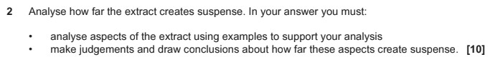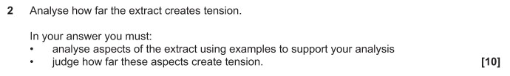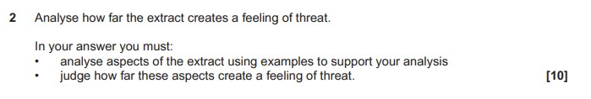
Preparation: Watch Vigil & The Avengers clips - consider how different aspects of media language work together to create a certain mood or theme.
This could be: humour, suspense, excitement, a close relationship, heroes and villains. Spies, the patriarchy etc.
Mood created in the clip & specific reference to text | Media language examples
  Personal judgement - does it
  create this mood effectively?
VIGIL | C  E  S  M
AVENGERS | C  E  S  M

Question 3 (15 mark)
You must analyse the clip & make a clear judgement. In this question it states ‘full course of study’ this means you should mention something about two key concepts (LIAR). These concepts will be in the question.
You should include analysis of how the extract reflects ‘media contexts’ this means how it reflects the real world & time that the show was based. E.g. Avengers reflects changing feminism, the cold war, post WW2 etc.
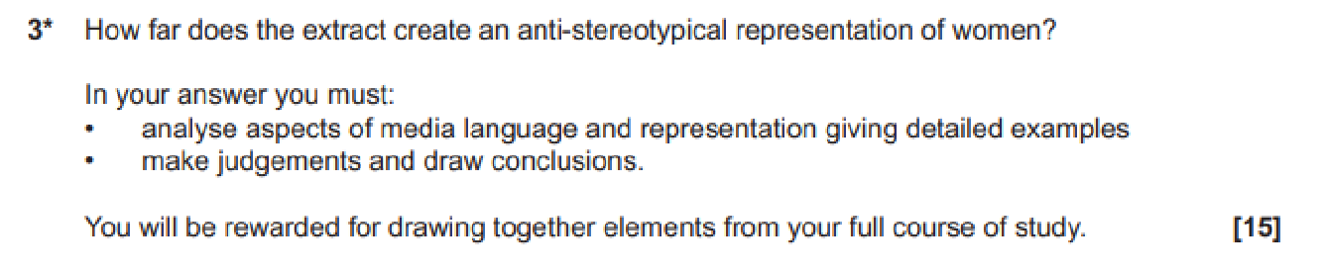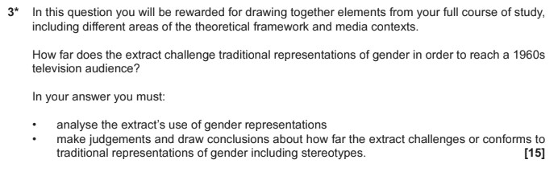
Preparation: Visit the 3 min clips again & develop your longer response style.
 | VIGIl | The Avengers
Language
Industry
Audience
Representation
Media Contexts
Judgement & Conclusion
Question 4 (5 marks) Knowledge question about any area of the theoretical framework (LIAR).
Preparation: Prepare for a range of questions across all aspects of the theoretical framework.
 | Point | Explanation/Example
 | 1
  Two ways audiences can watch
  TV after its initial broadcast
 | 2
 | 1
  Two ways television
  programmes are funded
 | 2
 | 1
  Two ways television is
  regulated
 | 2
The difference between commercial & PSB TV | 1
The difference between commercial & PSB TV | 2
 | 1
  Two ways the BBC spend their
  licence fee
 | 2
 | 1
  Explain two factors that affects
  how audiences interpret
  representations in TV
  programmes
 | 2
Two ways that the uses and gratifications theory applies to television. (PESS) | 1
 | 2

Question 5 (10 marks) VIGIL
This question is based on context. You will be asked about the show you have not been shown in the exam.
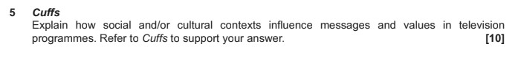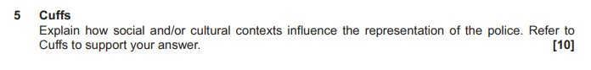
Preparation: Be prepared with specific examples from Episode 1 that cover a
range of potential media contexts.
Context
Example(s) from Vigil - characters/storylines/representations
roles
Gender
to
Attitude
es
sexualiti
Multicult
uralism
ng
Changi
attitude
to age
Authority &
criminal
s

Question 5 (10 marks) THE AVENGERS
This question is based on context. You will be asked about the show you have not been shown in the exam.
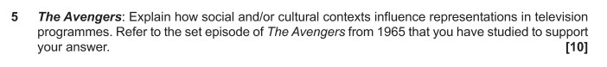
Preparation: Be prepared with specific examples from Season 4 Episode 1 ‘The Town of No Return’
that cover a range of potential media contexts.
 | Context | Example(s) from The Avengers - characters/storylines/representations
Gender roles
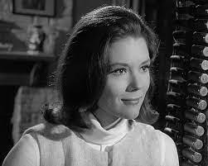
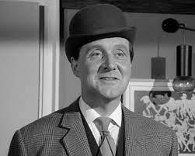
attitude to
sexualities
 | Multiculturalism
Changing
attitude to age

Heroes and
villains

Paper 1. Section B: Promoting Media
4 Questions. The Lego Movie & videogame.

Question 6 (1 mark)
Knowledge of the film & video game industry and the companies involved in The Lego Movie & videogame.
Preparation: write a short definition of each of the following terms/companies. What is their
involvement in the Lego Movie franchise?
promotion
franchise
distribution
conglomerate
tent-pole production
synergy
vertical integration
platform
feminism
stereotype
Warner Bros
TT Fusion
WB Games
BBFC
PEGI
VSC
ASA
DC Comics

Question 7 (4 marks)
This question tests your knowledge of the film & video game industry. You must explain using examples from The Lego Movie franchise naming the companies involved and industry terminology.
Preparation: Explain each of the following. Give examples from The Lego Movie franchise.
 | Explanation | Example
Two ways that films are funded | 1
Two ways that films are funded | 2
 | 1
  Two advantages of being a
  media conglomerate
 | 2
 | 1
  Two ways tent-pole productions
  are beneficial for a company
 | 2
Two benefits of releasing a videogame linked to a film | 1
Two benefits of releasing a videogame linked to a film | 2
 | 1
  Two benefits of vertical
  integration
 | 2
 | 1
  Two ways video games are
  funded
 | 2
 | 1
  Two ways media texts are
  regulated in the UK
 | 2

Question 8 (10 marks) Tests your ability to explain about industry, audience or both.
Preparation: Prepare for each of the following industry & audience ideas with examples
 | Example from The Lego Movie | E.g. Lego Movie Videogame
Active audiences
Merchandise
Surveillance (U&G)
Entertainment (U&G)
Personal Identity (U&G)
Social Relationships (U&G)
How the promotion targeted a
family audience

How different audiences are
targeted by promotion

Benefits of a tent-pole
production for WB & audiences

Explain how regulation can
shape promotional texts

Question 9 (10 marks) Test your ability to analyse the promotional material for The Lego Movie.The question will either focus on The Lego Movie trailer, The Ad Break or the poster campaign.
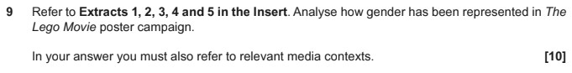
Preparation: Complete the following analysis notes about each of the set texts.
Posters | Ad Break | Trailer
Genre conventions | Genre conventions | Genre conventions
Intertextuality | Intertextuality | Intertextuality
Representations | Representations | Representations
Narrative | Narrative | Narrative
Audience targeting | Audience targeting | Audience targeting

Paper 2. Section A: Music
5 questions. Live Lounge, music video & MOJO.Question 1 (1 mark)
This question tests your knowledge of the music industry including regulation & ownership.
Preparation: write a short definition of each of the following. What is their link to the music set texts?
MOJO magazine
Bauer media
BBC
IPSO
Diversification
Conglomerate
Radio 1
PSB
Royal Charter
Ofcom
Niche market
Mass audience
Diversity
Distinctive
Convergence
Genre conventions
Globalisation
Product Placement
Multiculturalism
Celebrity culture
Mode of address
Question 2 (4 marks) This question will either be about BBC Radio 1’s Live Lounge or your set pair of music videos (Black Magic and Somebody to You). It is likely to test audience or industry knowledge. You must include specific examples from the set text to support your ideas.
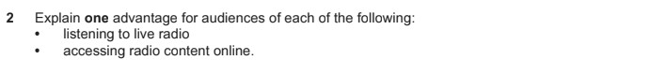
Preparation: prepare for questions about BBC Radio 1’s Live Lounge
 | Explanation | Example
Two ways Live Lounge meets the BBC’s PSB requirements Royal Charter)  reflect UK diversity/ innovative/ distinctive/ promote UK talent | 1
 | 2
One advantage of  - Live radio  - Online radio content analogue/ digital/ web/ BBC Sounds/ Youtube/ Socials | 1
 | 2
Two ways radio shows are promoted to an audience analogue/ digital/ web/ BBC Sounds/ Youtube/ Socials | 1
 | 2
Two ways audiences can  actively engage with radio shows | 1
Two ways audiences can  actively engage with radio shows | 2
 | 1
  Two ways that LIve Lounge
  demonstrates convergence
 | 2
Two ways Live Lounge appeals to the target audience of 15-29 year olds. | 1
 | 2
 | 1
  Two ways Live Lounge reflects
  audience diversity
 | 2

Question 3 (10 marks)
This extended question will be about music video or Live Lounge. You will have to give specific examples from the set text. It is likely to be about audience or representations.
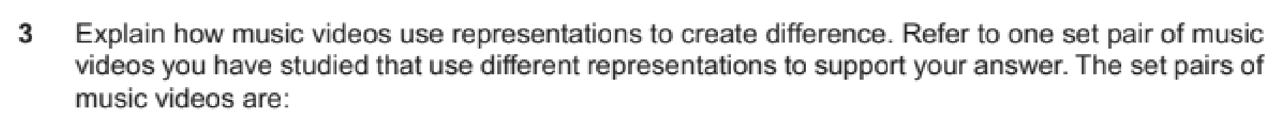
Preparation: Complete the following table with explanations & examples.
 | Black Magic | Somebody to you
Representation of relationships
Representation of masculinity
Representation of femininity
Stereotypes
Representations of
Celebrity/Fame
Representations of
America/The
City/Reality
How audiences are targeted by this video
How audiences my
relate to or identify with the video

Question 4 (5 marks)
Unseen front cover from MOJO magazine provided in the exam focused on language or representation.
Preparation: Complete analysis of theMOJO front covers focusing on language & representations
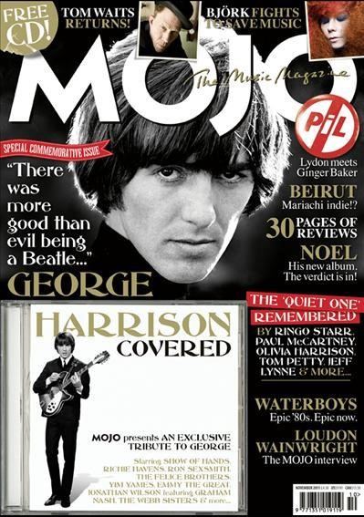 |  | Magazine conventions
 |  | Text/Font
 |  | Image
 |  | Representation of classic rock
 |  | Representation of musicians
 |  | Representation of gender
 | 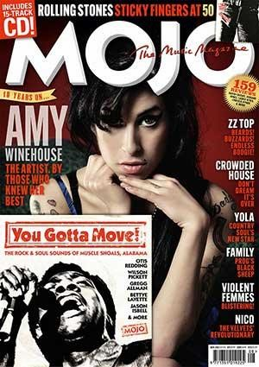 |  | Magazine conventions
 |  |  | Text/Font
 |  |  | Image
 |  |  | Representation of classic rock
 |  |  | Representation of musicians
 |  |  | Representation of gender

Question 5 (15 marks)
This is an extended question focused on media language. You will be asked to compare Extract 1 (MOJO magazine) and another front cover from a different music magazine. You should be able to analyse both extracts using terminology as well as give a clear judgement about the question.
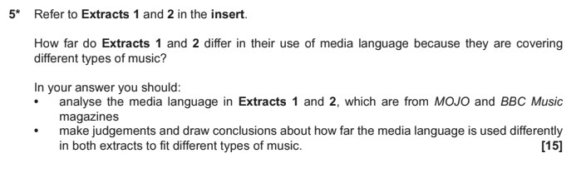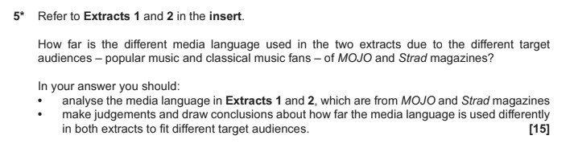
Preparation: Compare and contrast the two covers overleaf across language & representation. Use
magazine codes & conventions to assist you.
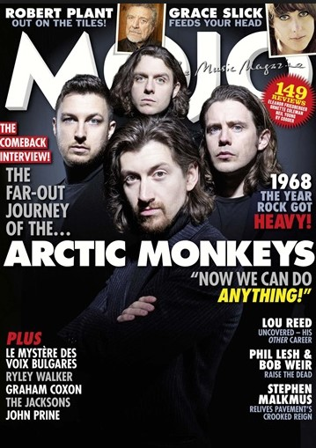
Sell lines
Insert image
Slogan
Masthead
Puff
Main image
Direct mode of address
Anchorage
Pull quote
Coverlines

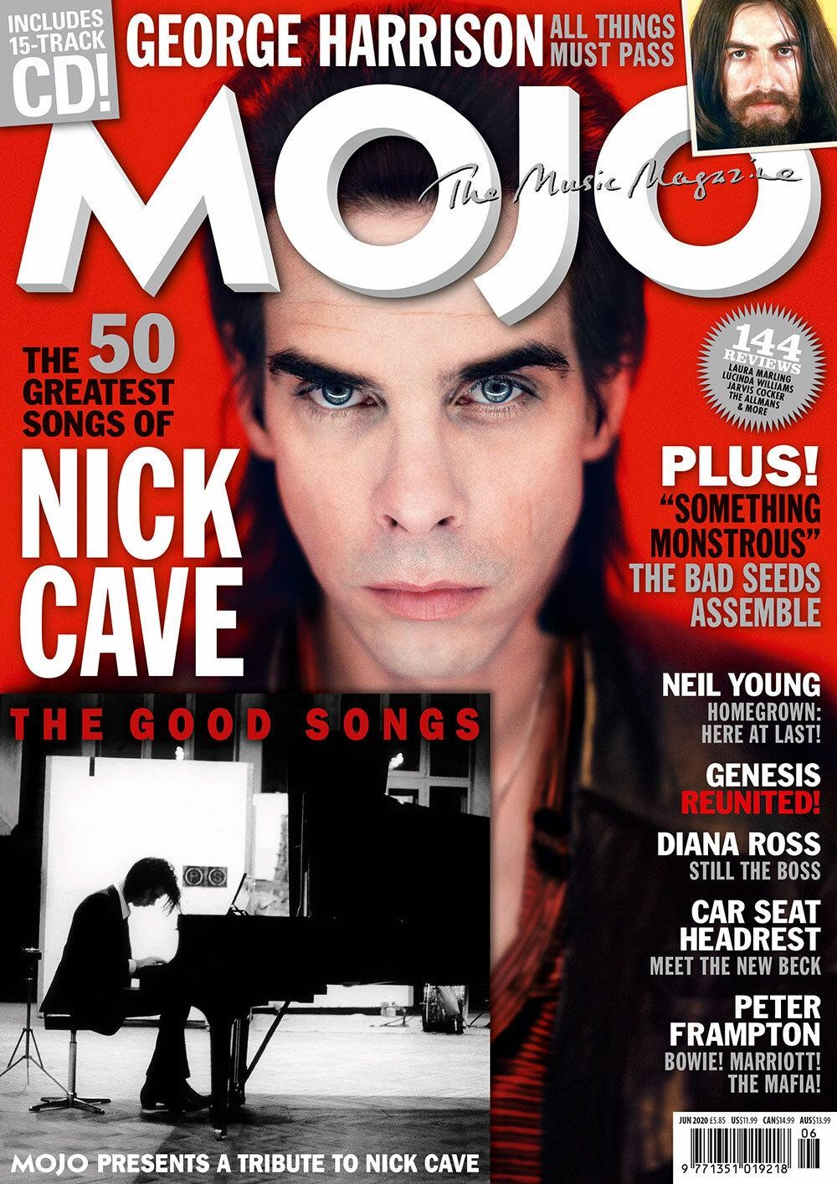 | 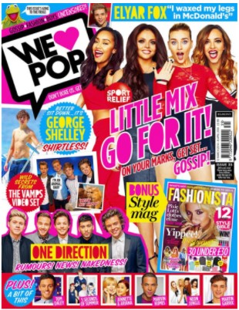
Magazine conventions
Text/Image/Colour
Representation of music genre
Representation of music stars
Representation of gender
Judgement & Conclusion - are they more similar or more different?

Paper 2. Section B: News
5 questions. The Observer 1960s & contemporary print & online.
Question 6 (1 mark) This question tests your understanding of the newspaper industry.
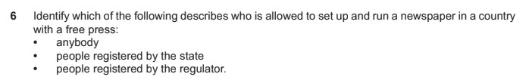
Preparation: Write a definition of each of the following. What is their link to The Observer?
Press freedom
IPSO
IMPRESS
Guardian Media Group
The Scott Trust
Broadsheet
Tabloid
Hybrid
Paywall
Conglomerate
Impartial
Right wing
Left wing
Clickbait
Hard/soft news
Asymmetrical layout
Intertextuality
Serif/sans serif
Skybox
Ideologies

Question 7 (4 marks)
This further tests your understanding of the newspaper industry. You should include real examples from The Observer & other news industry knowledge to support your answer.
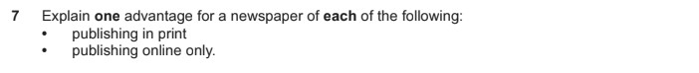
Preparation: Complete the following table:
 | Explan | ation | Examples
Explain two ways the print newspaper industry have diversified online | 1 |  | Online
 | 2 |  | Social Media
One advantage for a newspaper to  - Have an online edition  - Use social media | 1 |  | Online
 | 2 |  | Social Media
 | 1 |  | Online
  Explain why a newspaper
  would shut down its print
  edition and be online only
 | 2 |  | Social Media
 | 1 |  | Online
  Explain two ways online
  newspapers are funded
 | 2 |  | Social Media
t | 1 |  | Online
  Explain how the Observer
  incorporates hard and sof
  news
 | 2 |  | Social Media

Question 8 (5 marks)
This question will ask you to analyse the unseen extract in your exam insert. The analysis could be any key concept and will want you to use examples from the extract & media terminology.
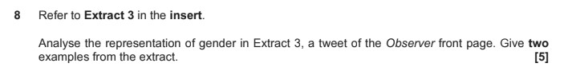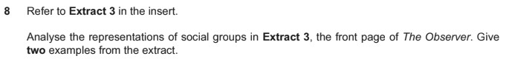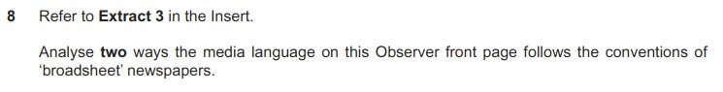
Preparation: Complete notes about the front cover of the extract below:
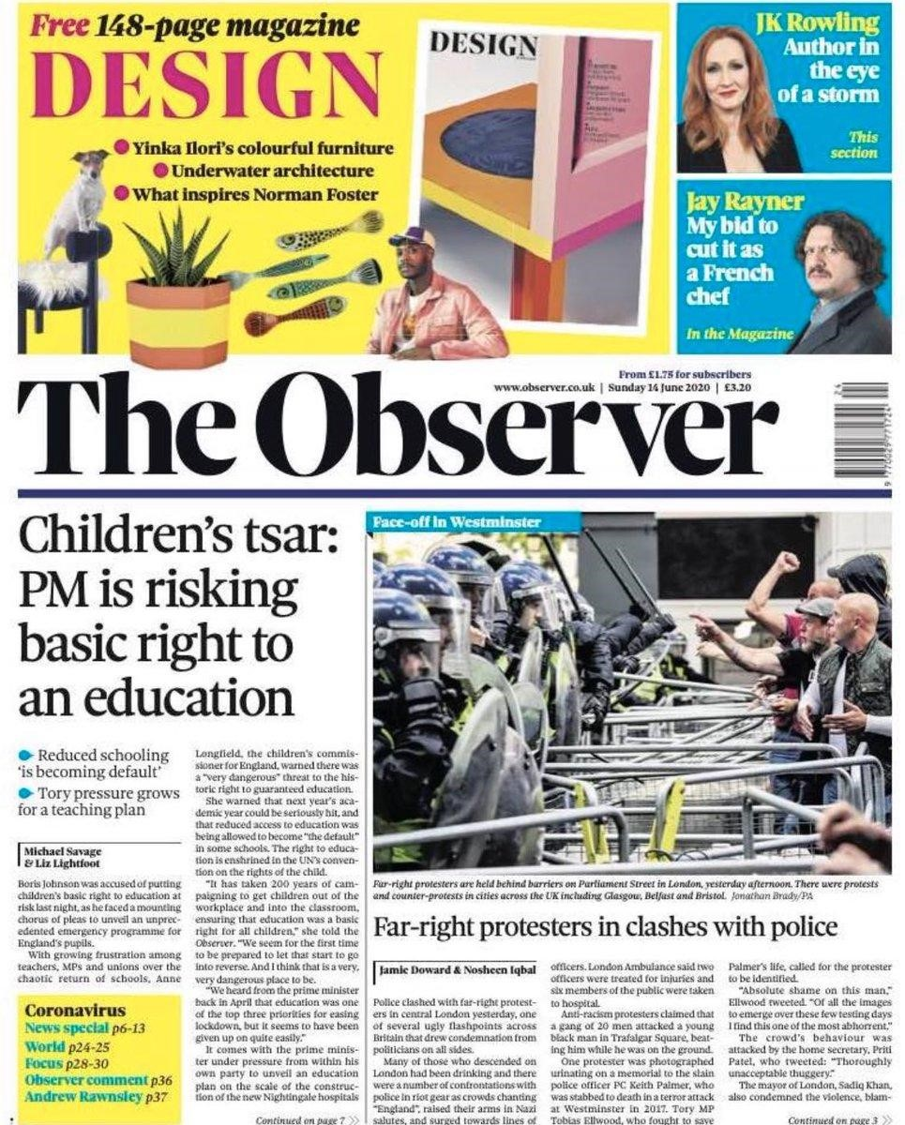 | Genre conventions
 | Image/Colour/Layout
 | Content/stories/topics
 | Representation of women
 | Representation of police/protestors
 | Representation of lifestyle
Values & ideologies of The Observer reflected through the front cover stories
Contexts:

Question 9 (15 marks)
You must analyse the extract & make a clear judgement. In this question it states ‘full course of study’ this means you should cover at least two of the key concepts (LIAR)
You should also include analysis of how the extract reflects ‘media contexts’ this means how it reflects the real world and time that the newspaper was written.
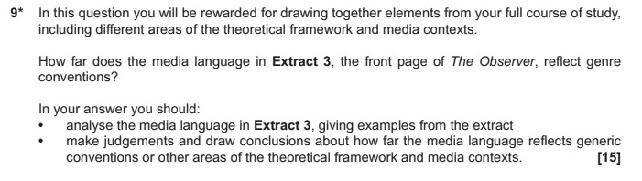
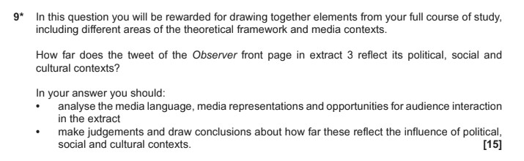
Preparation: Consider how this front cover reflects contemporary ‘media contexts’.
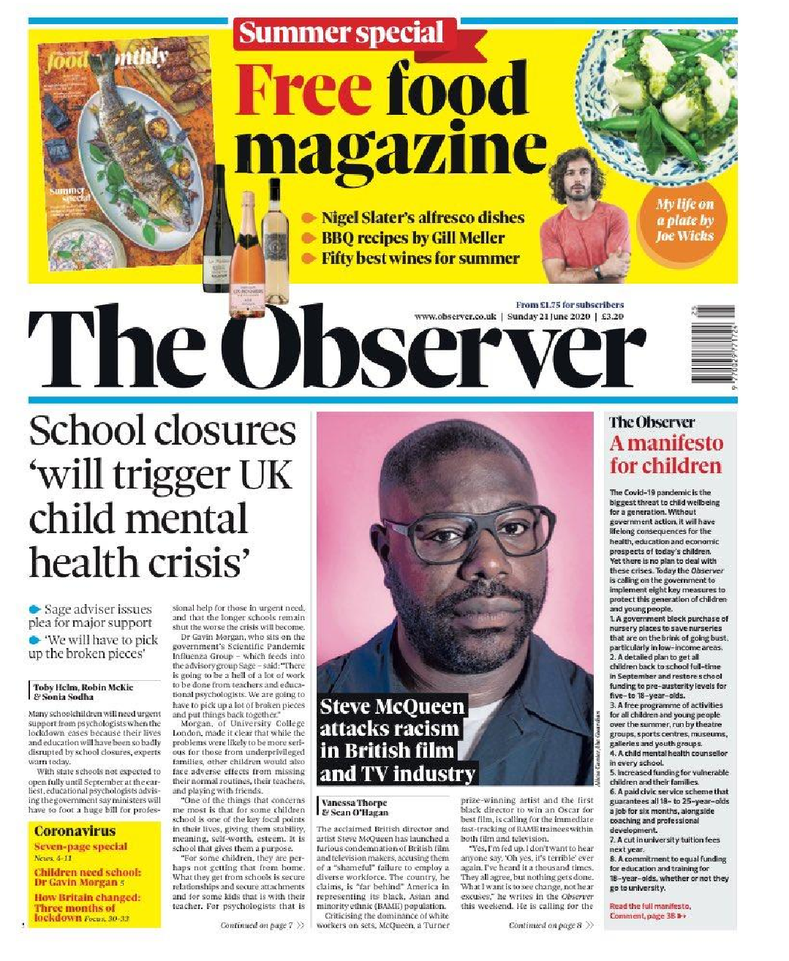 | Gender roles
 | Multiculturalism
 | Lifestyles
 | Democracy/Liberal viewpoint
 | Consumerism
 | Celebrity culture

Question 10 (10 marks)
This question wants you to explore media contexts in more detail. It could be based on historical contexts as below but could also be about contemporary news - or both.
Preparation: Complete the following table with headlines, stories ad details from across the three set
historical covers.
Context |  | Example story / Headline(s)
Gender equality
Patriarchy
Political change
Political divisions
The Cold War
Rise of student protest
Union strikes
Anti-racist movements
Multiculturalism
Patriotic society/Royalist
End of questions.

Checklist for revision & preparation


Paper 1 Section A: Television
Revise camerawork terminology
Revise editing terminology
Revise mise-en-scene terminology
Revise soundtrack terminology
Prepare for Question 1 = media language
Prepare for Question 2 = media language & judgement
Revise Cuffs and The Avengers knowledge
Prepare for Question 3 = All key concepts for TV
Prepare for Question 4 = Television industry & audience
Revise context examples from Cuffs & The Avengers
Prepare for Question 5 = media contexts in Cuffs & The Avengers
Paper 1 Section B: Promoting Media
Revise film & videogame industry terminology & companies
Prepare for Question 6 = one mark industry terminology
Revise content examples from The Lego Movie franchise
Prepare for Question 7 = industry & audience knowledge & examples
Prepare for Question 8 = industry & audience knowledge & examples
Revise The Lego Movie promotion (trailer, ad break & posters)
Prepare for Question 9 = film promotion

Paper 2 Section A: Music
Revise music industry terminology & companies
Prepare for Question 1 = one mark music industry
Revise content examples from Radio 1’s Live Lounge
Prepare for Question 2 = Radio 1’s Live Lounge & audience
Revise representation examples from both music videos
Prepare for Question 3 = music videos & representations
Revise magazine genre conventions
Prepare for Question 4 = MOJO magazine language & representations
Prepare for Question 5 = Magazine comparison
Paper 2 Section B: News
Revise news industry terminology & companies
Prepare for Question 6 = one mark news industry
Revise content examples from online & social media Observer
Prepare for Question 7 = The Observer online & social media industries
Revise genre conventions of newspapers
Prepare for Question 8 = newspaper language & representations
Revise LIAR content for The Observer
Prepare for Question 9 = Newspapers LIAR & media contexts
Revise historical context examples from the 1960s Observer
Prepare for Question 10 = Historical contexts

